

**Kings Birthday Weekend**

**1st - 2nd June 2024**

**663 Swanson Road, Swanson, Auckland**

**Contact: 09 833 9013 or**

**welfare@swansonrsa.co.nz**

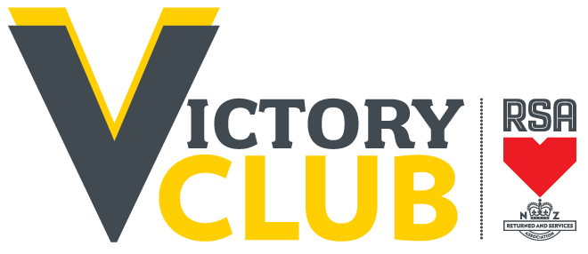

**Victory Darts Tournament**

**Hosted by**

**Swanson Memorial RSA**