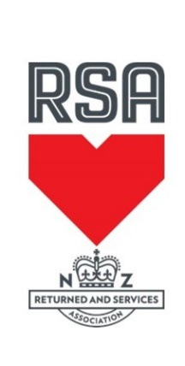

**RNZRSA National Snooker Singles 2023**

The Tokoroa Club Inc in conjunction with Tokoroa RSA is proud to host the 2023 RNZRSA Snooker Singles over Labour weekend 21st and 22nd of October 2023

To enter you must be a financial member of an RSA. Entry is open to all RSA Members

Cost to enter is $80.00 per player payment must be made at time of entry

Entry is restricted to 64 entries if more than 64 players the first names on the entry form will have priority

To enter please fill out the following form and send to:

RNZRSA National Snooker Singles, P O Box 53, TOKOROA 3444 or

email to: tokclubmgr@xtra.co.nz

No later than the 13th October 2023

Payment may be made to the following account BNZ 02-0464-0026188-03

Please remember to either post or email the entry form.

Yours Sincerely

Michelle Felton

Michelle Felton

Tournament Convenor

Tokoroa Club Inc

P O Box 53

TOKOROA 3444

Phone 07 8865 139 Extension 3

Email: tokclubmgr@xtra.co.nz 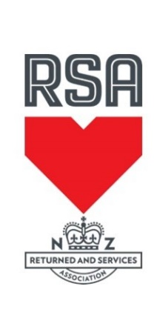

**RNZRSA National Snooker Singles 2023**

21st & 22nd October 2023

**Entry Form**

Club Name: __________________________ Contact Phone: _____________

Contact Person: ___________________________________________________

Email Address: ____________________________________________________

**ENTRY FEE $80 PER PERSON**

Entries must be received by 5pm Friday 13th October 2023

Please indicate whether Returned, Service or Associate.

**Players Names Club Number RET/SER/Ass**

1. **________________________________________________________________________**
2. **________________________________________________________________________**
3. **________________________________________________________________________**
4. **________________________________________________________________________**
5. **________________________________________________________________________**
6. **________________________________________________________________________**

Total Entry Fee to be Paid (number of entrants X $80) = _____________________________

**I declare that the above-named persons are current financial members of the RSA and that the membership categories as indicated are correct**

**Signed by Secretary/Manager: _____________________________ Date: ___________**

Tokoroa Club Inc

P O Box 53

TOKOROA 3444

Phone 07 8865 139 Extension 3

Email: tokclubmgr@xtra.co.nz

**Accommodation in Tokoroa**

**Clifton Court Motel** 111 Main Road, Tokoroa Ph 07 886 4579

Website: www.cliftoncourtmotel.co.nz

Most of the units at Clifton Court Motel have been completely renovated back to new, with new furnishings and large flat screen TV's. Both business and family travellers can expect to find an option to suit, with our spacious, ground floor, smoke free units at affordable prices. Choose from Standard or Family Rooms all with Queen Size beds, tea and coffee facilities & FREE Ultra Fast Wireless Internet (Wi-Fi). The recent addition of our executive units offer the most discerning traveller that extra night of luxury and comfort.  
  
The South Waikato region abounds with wonderful natural attractions, all within easy access from Tokoroa. Clifton Court Motel is conveniently located on State Highway 1, only a short walk from the town centre, restaurants, cinema and sporting facilities.  
  
We strive to make your stay an enjoyable one, and look forward to welcoming you soon...

**Redwood Lodge Motel** State Highway 1 North, Tokoroa Ph 0800 545 645

Website: www.redwoodlodgemotel.co.nz

11 spacious ground-floor units (all non-smoking). 3 studio, 2 x 1-bedroom, 6 x 2-bedroom units (sleep 1-6). Full cooking facilities in all units. Cooked and continental breakfasts are available. Guest BBQ area. Sky TV. WiFi. 24Hr Satellite security System. Ample off-street parking. Rural setting on northern edge of Tokoroa, 3 minutes from town centre and restaurants. Close vicinity to golf courses, sports and recreational facilities, indoor swimming complex and scenic walking tracks.

**Campervan Parking at Tokoroa Club**

53 Chambers Street, Tokoroa Ph 07 8865 139

Our club is an official Park over Property for members of NZMCA with Certified Self Containment

We have 6 sites with power and water available for your comfort during your stay. You must have a current Electrical WOF to use these power connections

Charge $10 per vehicle per night